**Part A**

This part of the assignment uses a sample of the CIFAR-10 dataset: <https://www.cs.toronto.edu/~kriz/cifar.html>

The dataset contains RGB colour images of size 32 X 32 and their labels from 0 to 9. You will be using the batch-1 of the dataset, which contains 10,000 training samples. Testing is done on 2,000 test samples. The training data and testing data are provided in files ‘data_batch_1’ and ‘test_batch_trim’ files, respectively. Sample code is given in file start_project_2a.py

Design a convolutional neural network consisting of:

• An Input layer of 3x32x32 dimensions

• A convolution layer 𝐶1 of 50 filters of window size 9x9, VALID padding, and ReLU neurons. A

max pooling layer 𝑆1 with a pooling window of size 2x2, with stride = 2 and padding = 'VALID'.

• A convolution layer 𝐶2 of 60 filters of window size 5x5, VALID padding, and ReLU neurons. A

max pooling layer 𝑆2 with a pooling window of size 2x2, with stride = 2 and padding = 'VALID'.

• A fully connected layer 𝐹3 of size 300.

• A softmax layer 𝐹4 of size 10

**1. Train the network by using mini-batch gradient descent learning. Set batch size =128, and learning rate 𝛼 = 0.001. Images should be scaled.**

a. Plot the training cost and the test accuracy against learning epochs.

For this question, I tried to run two twice, each time with a different stddev (values below).

**First run (last 10 iterations printed):**

iter 990: test accuracy 0.404, training loss 0.915385

iter 991: test accuracy 0.3895, training loss 0.904191

iter 992: test accuracy 0.3825, training loss 0.910298

iter 993: test accuracy 0.3765, training loss 0.897333

iter 994: test accuracy 0.367, training loss 0.907967

iter 995: test accuracy 0.386, training loss 0.90573

iter 996: test accuracy 0.389, training loss 0.94335

iter 997: test accuracy 0.388, training loss 0.898074

iter 998: test accuracy 0.368, training loss 0.910017

iter 999: test accuracy 0.377, training loss 0.904029

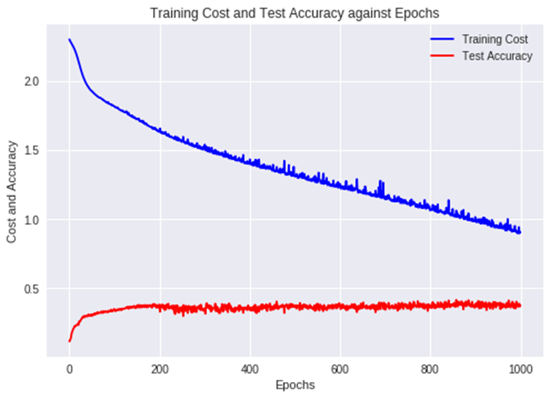

Number of epochs used: 1000

Stddev used for conv1_w => stddev=1.0 / np.sqrt(NUM_CHANNELS * 9 * 9)

Stddev used for conv2_w => stddev=1.0 / np.sqrt(cl1_num * 5 * 5)

Stddev used for full_w => stddev=1.0 / np.sqrt(dim)

Stddev used for softmax_w => 1.0/ np.sqrt(300)

**Second run (last ten iterations printed):**

iter 990: test accuracy 0.422, training loss 0.535053

iter 991: test accuracy 0.406, training loss 0.524679

iter 992: test accuracy 0.4085, training loss 0.525227

iter 993: test accuracy 0.3995, training loss 0.525629

iter 994: test accuracy 0.3905, training loss 0.512408

iter 995: test accuracy 0.3895, training loss 0.526694

iter 996: test accuracy 0.404, training loss 0.554735

iter 997: test accuracy 0.4005, training loss 0.50811

iter 998: test accuracy 0.4095, training loss 0.524067

iter 999: test accuracy 0.3915, training loss 0.530446

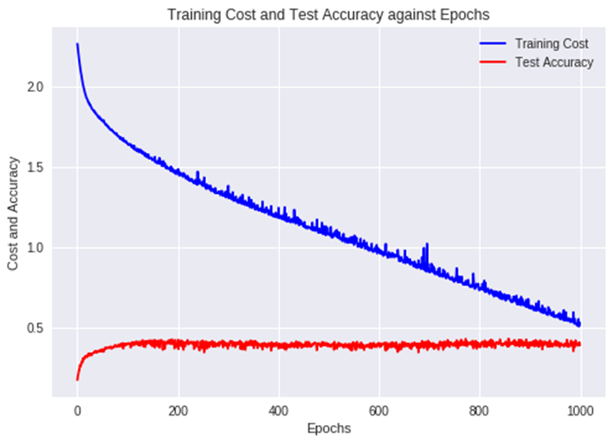

Number of epochs used: 1000

Stddev used for conv1_w => stddev= np.sqrt(2) / np.sqrt(NUM_CHANNELS * 9 * 9)

Stddev used for conv2_w => stddev= np.sqrt(2) / np.sqrt(cl1_num * 5 * 5)

Stddev used for full_w => stddev= np.sqrt(2) / np.sqrt(dim)

Stddev used for softmax_w => np.sqrt(2) / np.sqrt(300)

**Conclusions:**

As shown from the two diagrams above, it seems like the test accuracy has not much difference but the training cost for the second run is better. In the second run, the standard deviation of a zero-mean Gaussian distribution is used instead of 1.0.

Also, from the diagrams, it appears that after 200 epochs the test accuracy does not seem to improve any more. The test accuracy is around 0.4. This may be because the image itself is of too low-resolution.

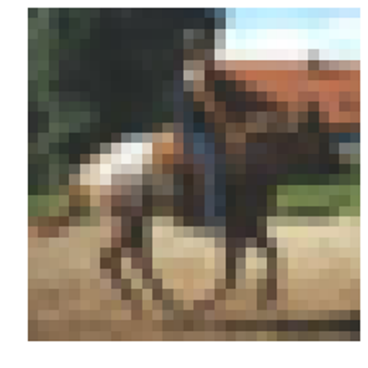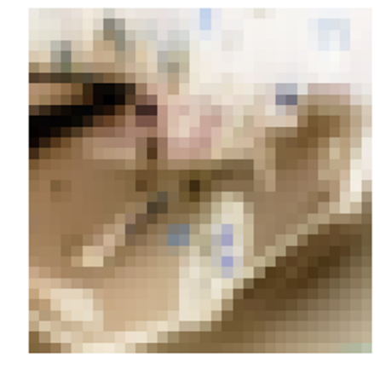

If the images are not just of size 32 x 32, perhaps higher resolution images can be filtered or pre-processed first before feeding in to the convolutional neural network.

b. For any two test patterns, plot the feature maps at both convolution layers (𝐶1 and 𝐶2) and pooling layers (𝑆1 and 𝑆2) along with the test patterns.

Test pattern 1:

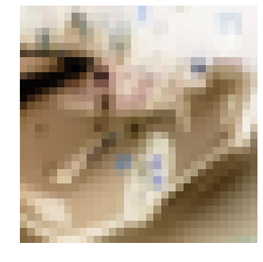

Convolution layer 𝐶1 of 50 filters of window size 9x9, VALID padding, and ReLU neurons:

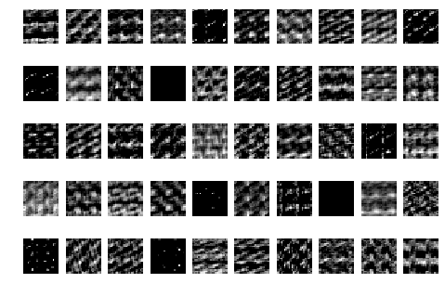

Max pooling layer 𝑆1 with a pooling window of size 2x2, with stride = 2 and padding = 'VALID':

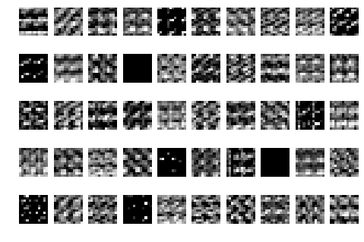

Convolution layer 𝐶2 of 60 filters of window size 5x5, VALID padding, and ReLU neurons:

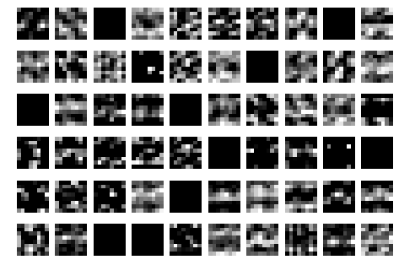

Max pooling layer 𝑆2 with a pooling window of size 2x2, with stride = 2 and padding = 'VALID':

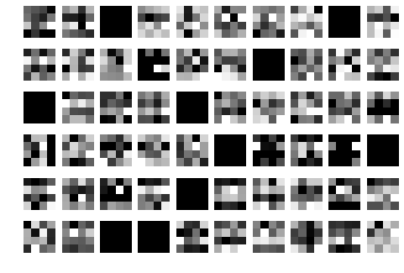

Test pattern 2:

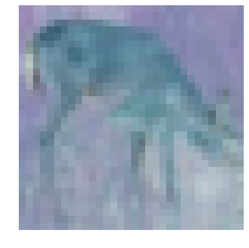

Convolution layer 𝐶1 of 50 filters of window size 9x9, VALID padding, and ReLU neurons:

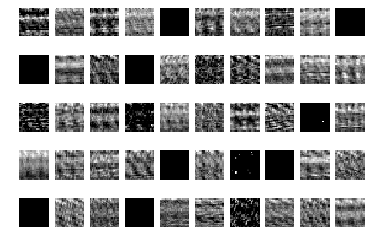

Max pooling layer 𝑆1 with a pooling window of size 2x2, with stride = 2 and padding = 'VALID':

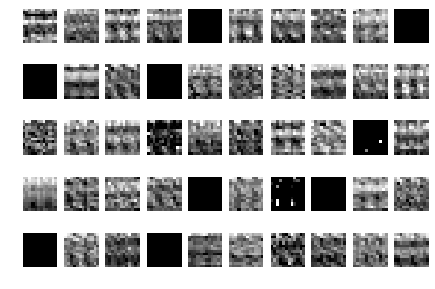

Convolution layer 𝐶2 of 60 filters of window size 5x5, VALID padding, and ReLU neurons: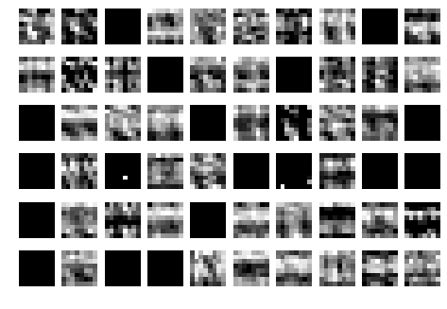

Max pooling layer 𝑆2with a pooling window of size 2x2, with stride = 2 and padding = 'VALID':

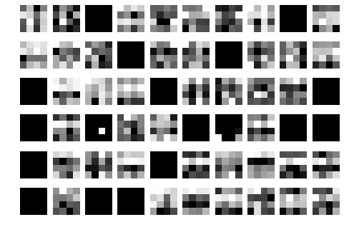

**2. Using a grid search, find the optimal numbers of feature maps for part (1) at the convolution layers. Use the test accuracy to determine the optimal number of feature maps.**

Grid search is a way of performing hyperparameter optimization, which is an exhaustive searching through a manually specified subset of the hyperparameter space of a learning algorithm.

In this case, I will be doing a broader grid search first to have a better idea of which filters works better, and then narrow it down with more iterations to see which is the most optimal number of feature maps.

Usually the initial layers represent generic features, while the deeper layers represent more detailed features (of the specific dataset that is used for training the model). Hence, for this grid search, I will be using less filters for C1 and more layers for C2.

The richness of possible representations increases because a given layer feeds directly from a layer below to form new kernels by combinations of the features in the layer below. For example, the first hidden layer forms it’s kernels by combinations of pixel values from the input, the combination of pixels is much richer than the pixels themselves, while the combination of pixel combinations (second hidden-layer) is even richer. And so on for the consecutive layers.

So the number of filters are incremented so as to be able to properly encode the increasingly richer and richer representations as the signal moves up the representational hierarchy in order to avoid the bottleneck effect.

For the grid search, I will be running:

* C1 with 40 filters and C2 with [60,80,100,120,140] filters
* C1 with 60 filters and C2 with [60,80,100,120,140] filters
* C1 with 80 filters and C2 with [80,100,120,140,160,180,200] filters
* C1 with 100 filters and C2 with [100,120,140,160,180,200] filters

There are most tests for C1 with 80 filters and C2 with 100 filters because they seem to perform better.

In addition to each graph, the last 10 iteration’s test accuracies are included as well.

epochs = 800

NUM_FEATURE_MAPS1 = [40]

NUM_FEATURE_MAPS2 = [60,80,100,120,140]

iter 700: test accuracy 0.366

iter 710: test accuracy 0.3625

iter 720: test accuracy 0.3735

iter 730: test accuracy 0.363

iter 740: test accuracy 0.3625

iter 750: test accuracy 0.3915

iter 760: test accuracy 0.3755

iter 770: test accuracy 0.379

iter 780: test accuracy 0.3825

iter 790: test accuracy 0.3695

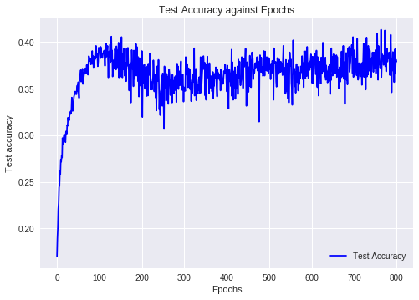

iter 700: test accuracy 0.392

iter 710: test accuracy 0.403

iter 720: test accuracy 0.393

iter 730: test accuracy 0.383

iter 740: test accuracy 0.375

iter 750: test accuracy 0.3875

iter 760: test accuracy 0.4

iter 770: test accuracy 0.391

iter 780: test accuracy 0.3975

iter 790: test accuracy 0.402

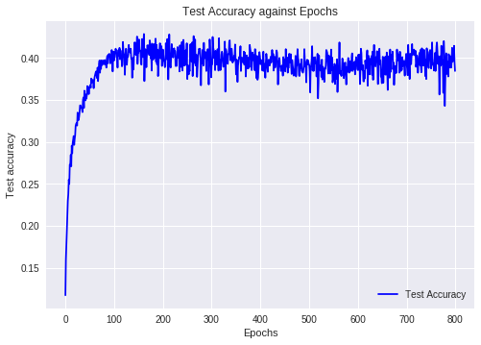

iter 700: test accuracy 0.394

iter 710: test accuracy 0.3935

iter 720: test accuracy 0.3825

iter 730: test accuracy 0.3895

iter 740: test accuracy 0.3825

iter 750: test accuracy 0.4005

iter 760: test accuracy 0.4025

iter 770: test accuracy 0.386

iter 780: test accuracy 0.3675

iter 790: test accuracy 0.367

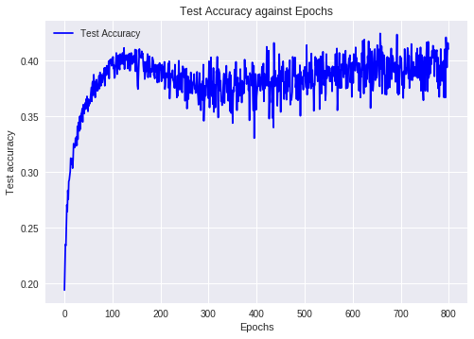

iter 700: test accuracy 0.4215

iter 710: test accuracy 0.4235

iter 720: test accuracy 0.4215

iter 730: test accuracy 0.427

iter 740: test accuracy 0.4095

iter 750: test accuracy 0.3985

iter 760: test accuracy 0.4215

iter 770: test accuracy 0.411

iter 780: test accuracy 0.433

iter 790: test accuracy 0.429

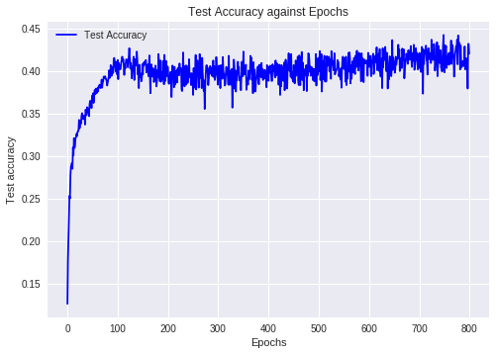

iter 700: test accuracy 0.3965

iter 710: test accuracy 0.405

iter 720: test accuracy 0.383

iter 730: test accuracy 0.402

iter 740: test accuracy 0.4065

iter 750: test accuracy 0.416

iter 760: test accuracy 0.421

iter 770: test accuracy 0.41

iter 780: test accuracy 0.424

iter 790: test accuracy 0.4075

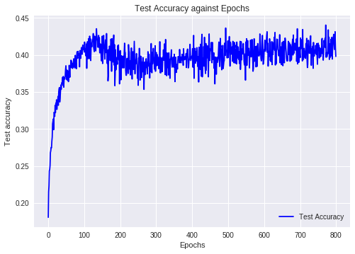

epochs = 800

NUM_FEATURE_MAPS1 = [60]

NUM_FEATURE_MAPS2 = [60,80,100,120,140]

iter 700: test accuracy 0.3605

iter 710: test accuracy 0.3575

iter 720: test accuracy 0.382

iter 730: test accuracy 0.352

iter 740: test accuracy 0.3655

iter 750: test accuracy 0.394

iter 760: test accuracy 0.383

iter 770: test accuracy 0.372

iter 780: test accuracy 0.3825

iter 790: test accuracy 0.374

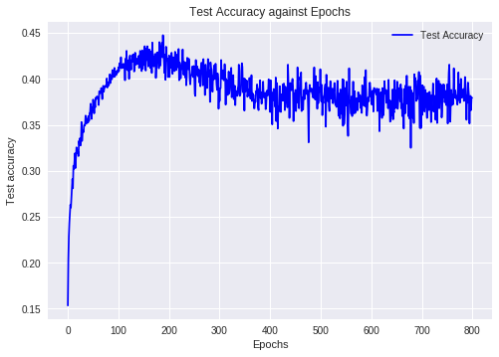

iter 700: test accuracy 0.4065

iter 710: test accuracy 0.4035

iter 720: test accuracy 0.3985

iter 730: test accuracy 0.398

iter 740: test accuracy 0.368

iter 750: test accuracy 0.406

iter 760: test accuracy 0.412

iter 770: test accuracy 0.416

iter 780: test accuracy 0.399

iter 790: test accuracy 0.3965

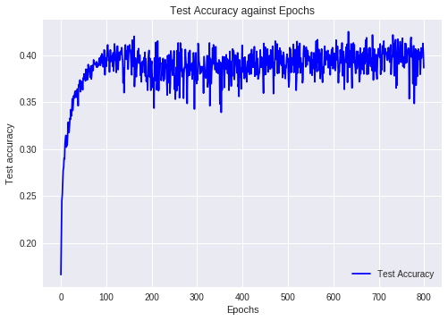

iter 700: test accuracy 0.406

iter 710: test accuracy 0.403

iter 720: test accuracy 0.3905

iter 730: test accuracy 0.4025

iter 740: test accuracy 0.3895

iter 750: test accuracy 0.414

iter 760: test accuracy 0.4075

iter 770: test accuracy 0.388

iter 780: test accuracy 0.3655

iter 790: test accuracy 0.384

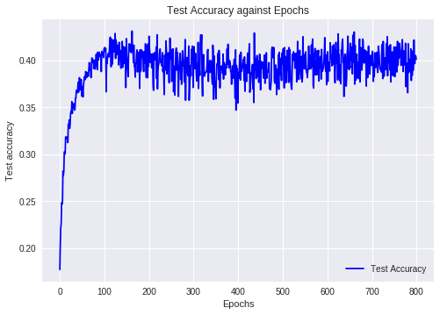

iter 700: test accuracy 0.4295

iter 710: test accuracy 0.4205

iter 720: test accuracy 0.4125

iter 730: test accuracy 0.409

iter 740: test accuracy 0.4065

iter 750: test accuracy 0.415

iter 760: test accuracy 0.415

iter 770: test accuracy 0.4225

iter 780: test accuracy 0.411

iter 790: test accuracy 0.4225

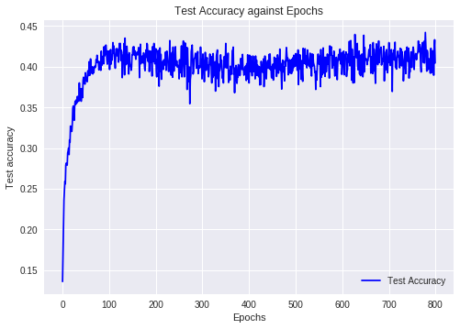

iter 700: test accuracy 0.3925

iter 710: test accuracy 0.3985

iter 720: test accuracy 0.386

iter 730: test accuracy 0.401

iter 740: test accuracy 0.391

iter 750: test accuracy 0.4065

iter 760: test accuracy 0.415

iter 770: test accuracy 0.405

iter 780: test accuracy 0.41

iter 790: test accuracy 0.4065

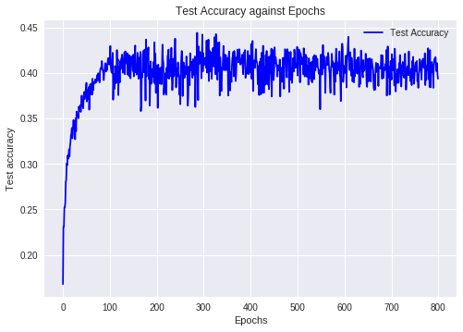

epochs = 800

NUM_FEATURE_MAPS1 = [80]

NUM_FEATURE_MAPS2 = [80,100,120,140,160,180]

iter 700: test accuracy 0.3955

iter 710: test accuracy 0.389

iter 720: test accuracy 0.396

iter 730: test accuracy 0.3865

iter 740: test accuracy 0.3925

iter 750: test accuracy 0.4155

iter 760: test accuracy 0.411

iter 770: test accuracy 0.3835

iter 780: test accuracy 0.42

iter 790: test accuracy 0.412

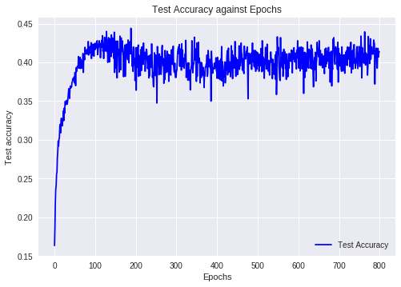

iter 700: test accuracy 0.424

iter 710: test accuracy 0.4215

iter 720: test accuracy 0.4225

iter 730: test accuracy 0.411

iter 740: test accuracy 0.39

iter 750: test accuracy 0.4205

iter 760: test accuracy 0.439

iter 770: test accuracy 0.4145

iter 780: test accuracy 0.419

iter 790: test accuracy 0.428

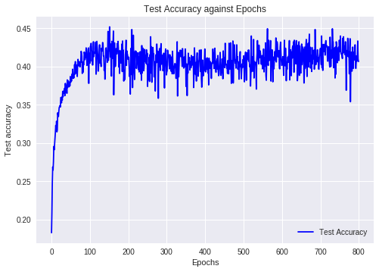

iter 700: test accuracy 0.434

iter 710: test accuracy 0.4305

iter 720: test accuracy 0.409

iter 730: test accuracy 0.4185

iter 740: test accuracy 0.407

iter 750: test accuracy 0.425

iter 760: test accuracy 0.428

iter 770: test accuracy 0.3955

iter 780: test accuracy 0.3785

iter 790: test accuracy 0.408

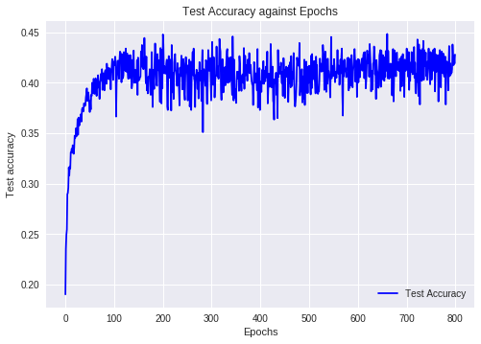

iter 700: test accuracy 0.42

iter 710: test accuracy 0.416

iter 720: test accuracy 0.42

iter 730: test accuracy 0.4015

iter 740: test accuracy 0.412

iter 750: test accuracy 0.434

iter 760: test accuracy 0.4325

iter 770: test accuracy 0.4055

iter 780: test accuracy 0.442

iter 790: test accuracy 0.409

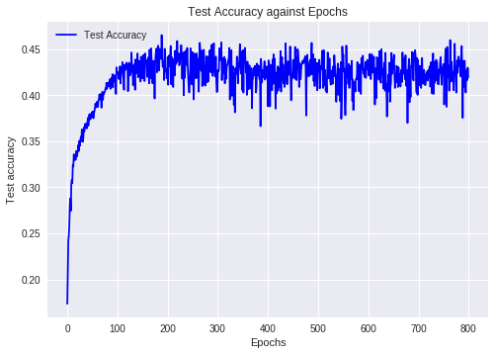

iter 700: test accuracy 0.427

iter 710: test accuracy 0.421

iter 720: test accuracy 0.4235

iter 730: test accuracy 0.419

iter 740: test accuracy 0.411

iter 750: test accuracy 0.4135

iter 760: test accuracy 0.4365

iter 770: test accuracy 0.4285

iter 780: test accuracy 0.4295

iter 790: test accuracy 0.4235

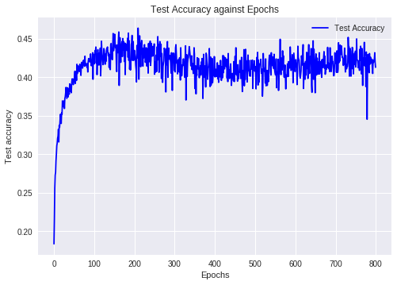

iter 700: test accuracy 0.406

iter 710: test accuracy 0.4035

iter 720: test accuracy 0.425

iter 730: test accuracy 0.4095

iter 740: test accuracy 0.4005

iter 750: test accuracy 0.422

iter 760: test accuracy 0.432

iter 770: test accuracy 0.4125

iter 780: test accuracy 0.4245

iter 790: test accuracy 0.4115

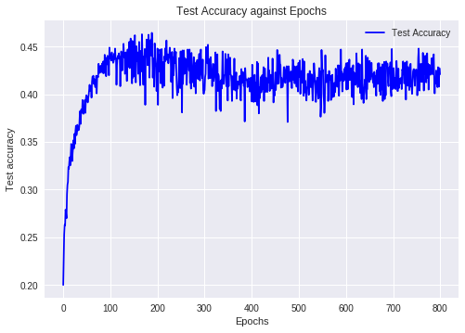

iter 700: test accuracy 0.43

iter 710: test accuracy 0.426

iter 720: test accuracy 0.4315

iter 730: test accuracy 0.4185

iter 740: test accuracy 0.413

iter 750: test accuracy 0.428

iter 760: test accuracy 0.4335

iter 770: test accuracy 0.43

iter 780: test accuracy 0.4265

iter 790: test accuracy 0.4225

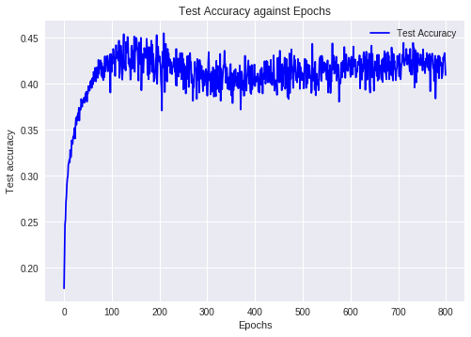

epochs = 1000

NUM_FEATURE_MAPS1 = [100]

NUM_FEATURE_MAPS2 = [100,120,140,160,180,200]

iter 900: test accuracy 0.426

iter 910: test accuracy 0.421

iter 920: test accuracy 0.441

iter 930: test accuracy 0.417

iter 940: test accuracy 0.417

iter 950: test accuracy 0.418

iter 960: test accuracy 0.4065

iter 970: test accuracy 0.406

iter 980: test accuracy 0.4215

iter 990: test accuracy 0.4215

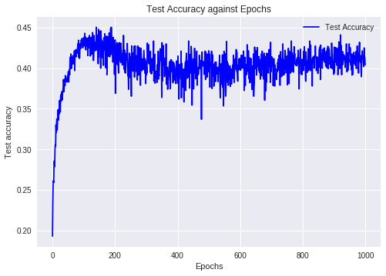

iter 900: test accuracy 0.402

iter 910: test accuracy 0.407

iter 920: test accuracy 0.4095

iter 930: test accuracy 0.4155

iter 940: test accuracy 0.4085

iter 950: test accuracy 0.4105

iter 960: test accuracy 0.3955

iter 970: test accuracy 0.402

iter 980: test accuracy 0.403

iter 990: test accuracy 0.4065

<matplotlib.figure.Figure at 0x7f7a7a26ba90>

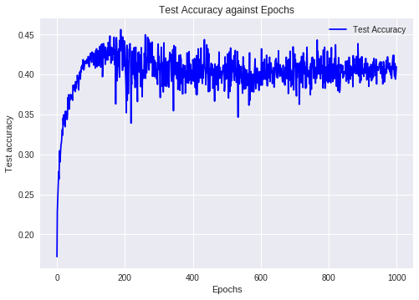

iter 900: test accuracy 0.414

iter 910: test accuracy 0.3885

iter 920: test accuracy 0.4045

iter 930: test accuracy 0.418

iter 940: test accuracy 0.4

iter 950: test accuracy 0.426

iter 960: test accuracy 0.427

iter 970: test accuracy 0.4125

iter 980: test accuracy 0.3995

iter 990: test accuracy 0.406

<matplotlib.figure.Figure at 0x7f7a7a2509b0>

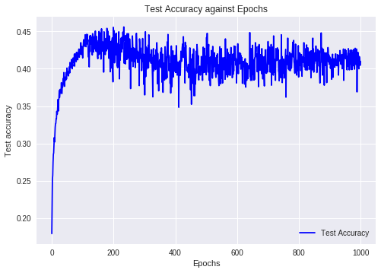

iter 900: test accuracy 0.4215

iter 910: test accuracy 0.4225

iter 920: test accuracy 0.439

iter 930: test accuracy 0.421

iter 940: test accuracy 0.4285

iter 950: test accuracy 0.4215

iter 960: test accuracy 0.4045

iter 970: test accuracy 0.407

iter 980: test accuracy 0.42

iter 990: test accuracy 0.4285

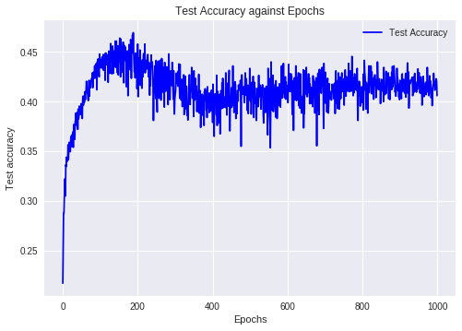

iter 900: test accuracy 0.419

iter 910: test accuracy 0.429

iter 920: test accuracy 0.4255

iter 930: test accuracy 0.4285

iter 940: test accuracy 0.431

iter 950: test accuracy 0.4305

iter 960: test accuracy 0.4185

iter 970: test accuracy 0.4245

iter 980: test accuracy 0.4155

iter 990: test accuracy 0.425

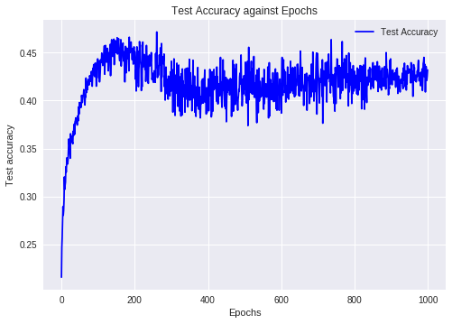

iter 900: test accuracy 0.4355

iter 910: test accuracy 0.4105

iter 920: test accuracy 0.4225

iter 930: test accuracy 0.4275

iter 940: test accuracy 0.4255

iter 950: test accuracy 0.43

iter 960: test accuracy 0.4365

iter 970: test accuracy 0.4285

iter 980: test accuracy 0.425

iter 990: test accuracy 0.4275

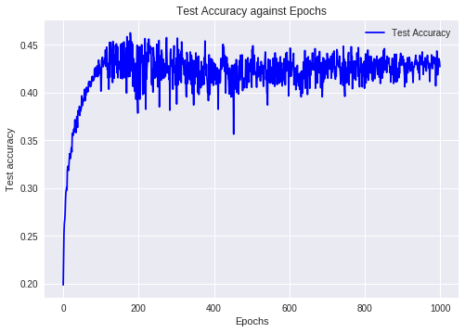

After getting these results, here are some of the **top few results**:

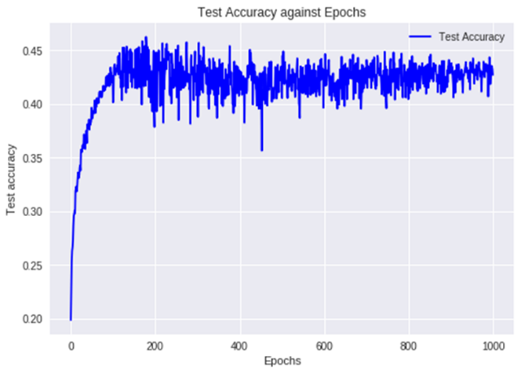(C1=100, C2=200)

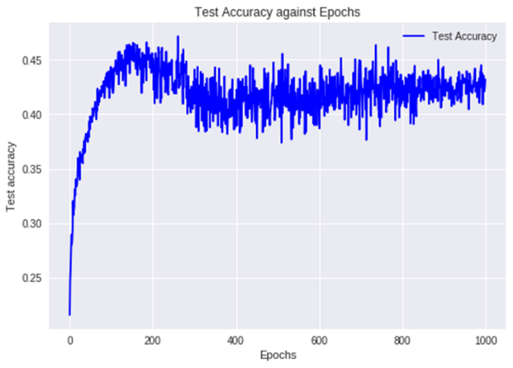 (C1=100, C2=180)

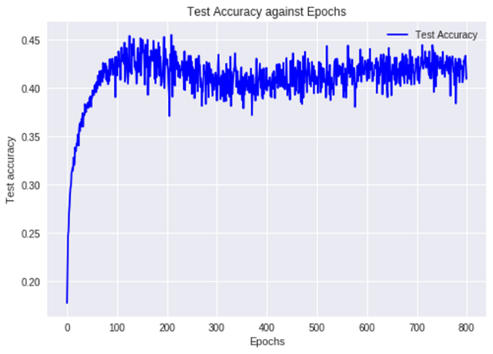(C1=80, C2=200)

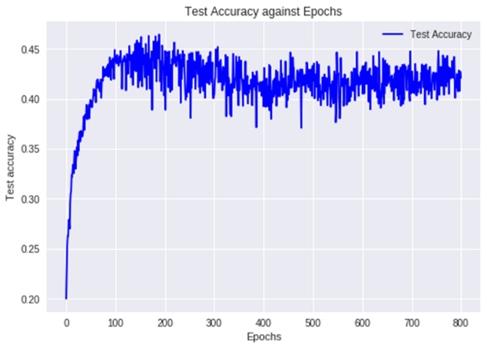 (C1=80, C2=180)

C1=100 filters, C2=200 filters is selected as the most optimal number of feature maps at the convolution layers.

**3. Using the optimal number of filters found in part (2), train the network by:**

a. Adding the momentum term with momentum 𝛾 = 0.1.

b. Using RMSProp algorithm for learning

c. Using Adam optimizer for learning

d. Adding dropout to the layers

Plot the training costs and test accuracies against epochs for each case.

**3a. Adding the momentum term with momentum 𝛾 = 0.1.**

C1=100 filters

C2=200 filters

Epochs = 1000

Deep neural networks have very complex error profiles. The method of momentum is

designed to accelerate learning, especially in the face of high curvature, small but

consistent gradients, or noisy gradients. When the error function has the form of a shallow ravine leading to the optimum and steep walls on the side, stochastic gradient descent algorithm tends to oscillate near the optimum. This leads to very slow converging rates. This problem is typical in deep

learning architecture. Momentum is one method of speeding the convergence along a narrow ravine. The momentum parameter # ∈ 0,1 indicates how many iterations the previous gradients are incorporated into the current update. The momentum algorithm accumulates an exponentially decaying moving average of past gradients and continues to move in their direction.

In tensorflow:

train_step = tf.train.MomentumOptimizer(learning_rate, 0.1).minimize(loss)

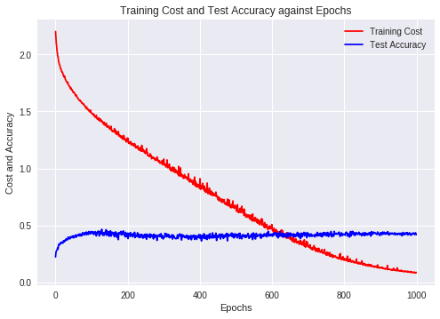

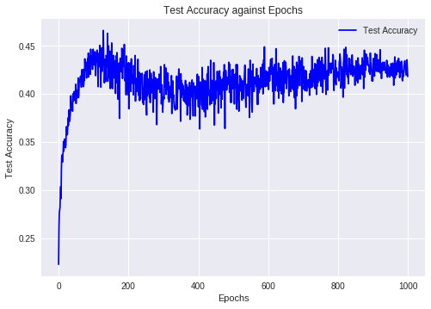

**3b. Using RMSProp algorithm for learning.**

train_step = tf.train.RMSPropOptimizer(learning_rate).minimize(loss)

RMSProp improves upon AdaGrad algorithms uses and exponentially decaying

average to decay from the extreme past gradient. RMSProp uses an exponentially

decaying average to discard the history from extreme past so that it can converge

rapidly after finding a convex region.



The parameter ᵨ controls the length of the moving average of gradients

RMSProp has been shown to be an effective and practical optimization algorithm for

deep neural networks.

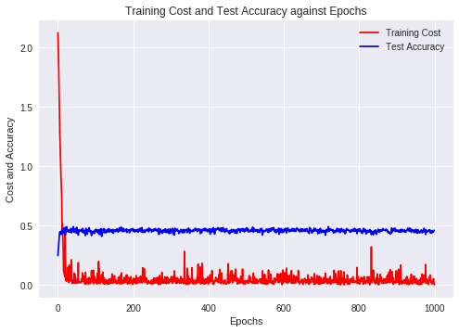

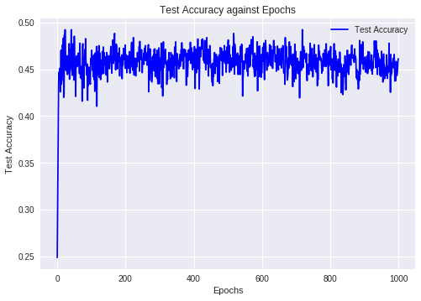

**3c. Using Adam optimizer for learning**

train_step = tf.train.AdamOptimizer(learning_rate).minimize(loss)

Adams optimizer combines RMSProp and momentum methods. Adam is generally regarded as fairly robust to hyperparameters and works well on many applications.

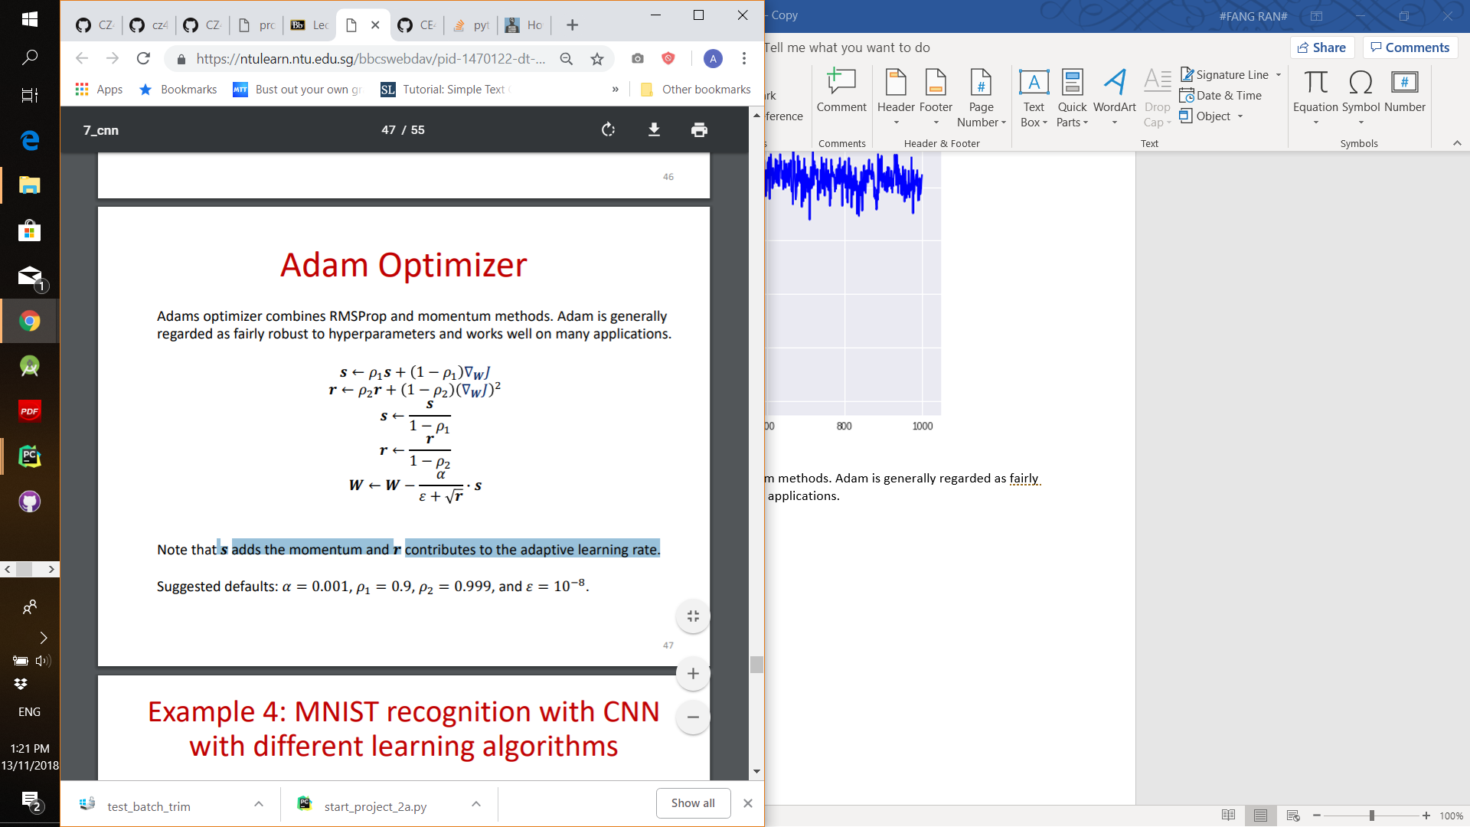

S adds the momentum and r contributes to the adaptive learning rate.

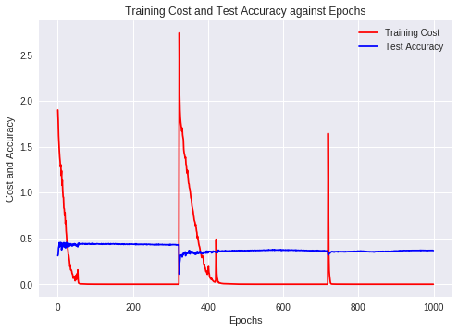

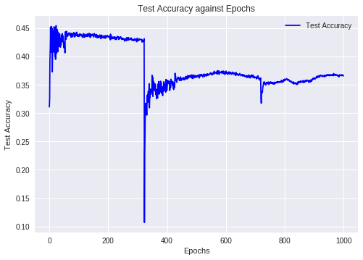

**Second run:**

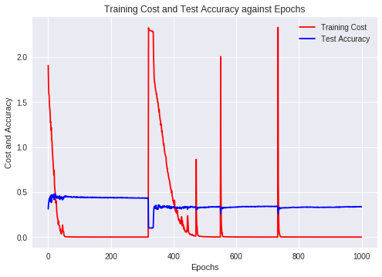

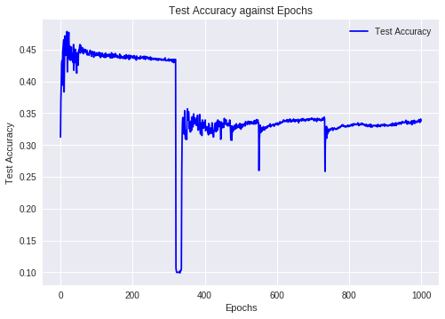

**d. Adding dropout to the layers**

Keep prob of 0.9 with tf.train.GradientDescentOptimizer(learning_rate).minimize(loss)

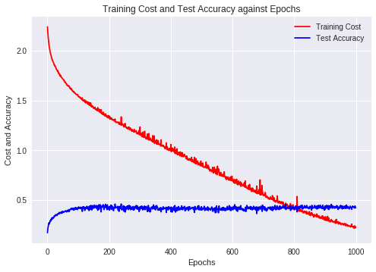

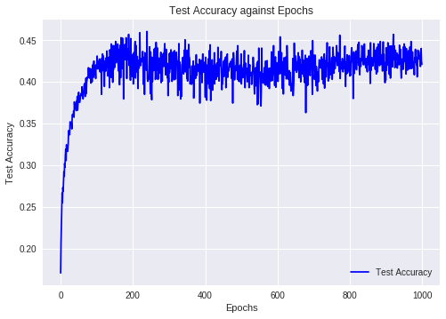

Keep prob of 0.9 with tf.train.RMSPropOptimizer(learning_rate).minimize(loss)

**4. Compare the accuracies of all the models from parts (1) - (3) and discuss their performances.**

The comparisons for parts (1) – (3) was explained in each section of (1) – (3) for better organization. Here are the more generalized conclusions:

**Part (1):** The test accuracy converges at around 0.4. Even with more epochs, the value did not increase. This is most likely because of the 32 by 32 low resolution of the individual images.

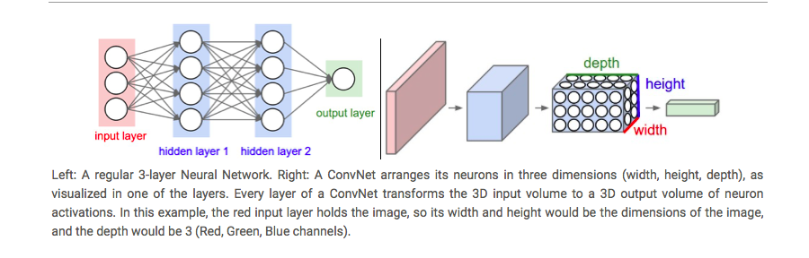

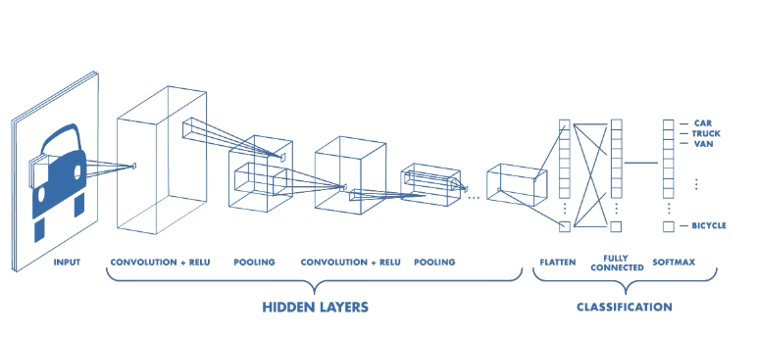

**Pooling layer:**

It is common to periodically insert a Pooling layer in-between successive Conv layers in a ConvNet architecture. Its function is to progressively reduce the spatial size of the representation to reduce the amount of parameters and computation in the network, and hence to also control overfitting. The Pooling Layer operates independently on every depth slice of the input and resizes it spatially, using the MAX operation. The most common form is a pooling layer with filters of size 2x2 applied with a stride of 2 downsamples every depth slice in the input by 2 along both width and height, discarding 75% of the activations. Every MAX operation would in this case be taking a max over 4 numbers (little 2x2 region in some depth slice). The depth dimension remains unchanged.

**Max pooling layer S1:**



**Max pooling layer S2:**



From these diagrams, it is observable that the spatial representation of the image is progressively reduced. This helps to reduce the amount of parameters and computation in the network, and hence to also control overfitting.

**An alternative to pooling:**

Many people dislike the pooling operation and think that we can get away without it. There has been proposals to discard the pooling layer in favor of architecture that only consists of repeated CONV layers. To reduce the size of the representation they suggest using larger stride in CONV layer once in a while. Discarding pooling layers has also been found to be important in training good generative models, such as variational autoencoders (VAEs) or generative adversarial networks (GANs). It seems likely that future architectures will feature very few to no pooling layers.

**Part (2):** C1=100 filters, C2=200 filters is the most optimal. For this question, I first tried doing a grid search across a larger search space and then did another grid search with a smaller search space after observing the results for the first search. Usually the initial layers represent generic features, while the deeper layers represent more detailed features (of the specific dataset that is used for training the model). Hence, for this grid search, I will be using less filters for C1 and more layers for C2.

The richness of possible representations increases because a given layer feeds directly from a layer below to form new kernels by combinations of the features in the layer below. For example, the first hidden layer forms it’s kernels by combinations of pixel values from the input, the combination of pixels is much richer than the pixels themselves, while the combination of pixel combinations (second hidden-layer) is even richer. And so on for the consecutive layers.

So the number of filters are incremented so as to be able to properly encode the increasingly richer and richer representations as the signal moves up the representational hierarchy in order to avoid the bottleneck effect.

For the grid search, I ran:

* C1 with 40 filters and C2 with [60,80,100,120,140] filters
* C1 with 60 filters and C2 with [60,80,100,120,140] filters
* C1 with 80 filters and C2 with [80,100,120,140,160,180,200] filters
* C1 with 100 filters and C2 with [100,120,140,160,180,200] filters

There are most tests for C1 with 80 filters and C2 with 100 filters because they seem to perform better.

Finally, the top few results are:

(C1=100, C2=200)

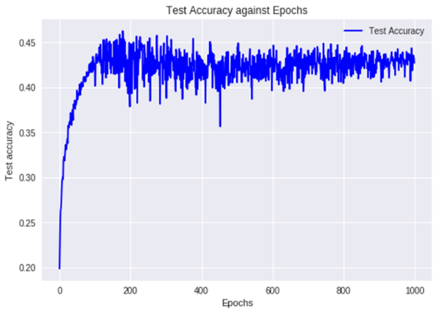

(C1=100, C2=180)

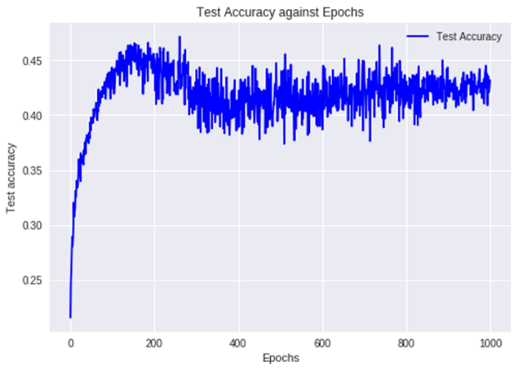

(C1=80, C2=200)



(C1=80, C2=180)

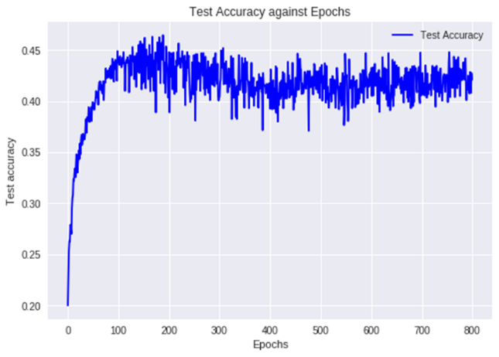

C1=100 filters, C2=200 filters is selected as the most optimal number of feature maps at the convolution layers.

**(3a-c):** RMSProp algorithm for learning seems to work best – it produces better test accuracies than the standard GradientDescentOptimizer. The test accuracy does not fluctuate too much across the epochs and the test accuracy is pretty consistent at the value of slightly higher than 0.45. Out of all the alternative training methods, the AdamOptimizer seems to produce worst results – it does not seem to be converging properly and fluctuates around too much. This is despite running it for a few times. Explanations of each algorithm and the diagrams generated are provided in Section 3 above for better organization.

**(3d):** Keep prob of 0.9

Testing with dropping out at different layers and not dropping out at different layers.

Using the RMSProp algorithm:

Dropping at C1, C2 and full layer. Drop out after each relu activation function:

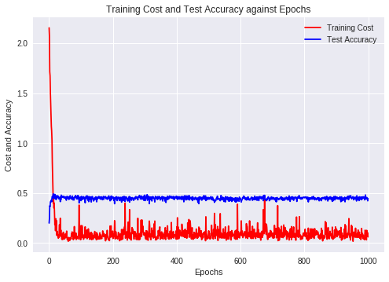

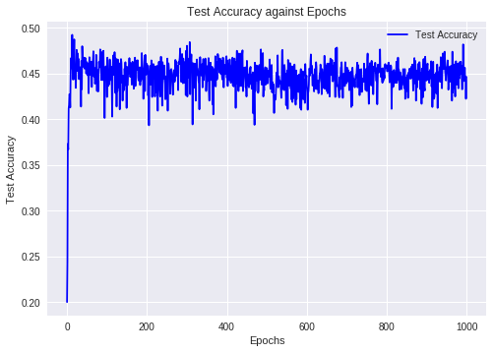

Dropping at C1 and C2 only.

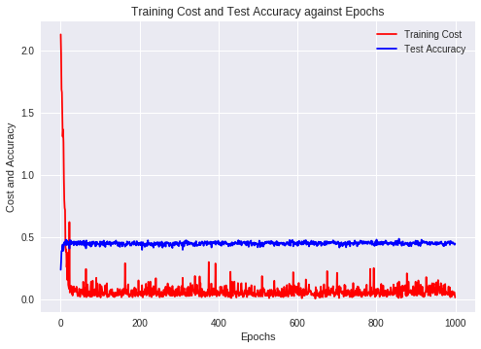

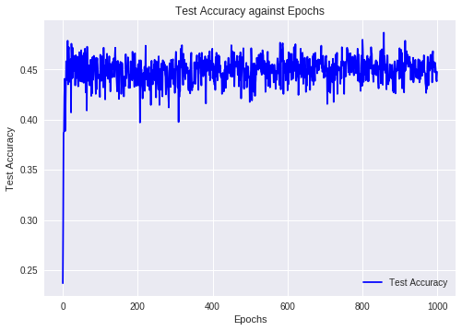

Dropping at the fully connected layer before softmax layer.

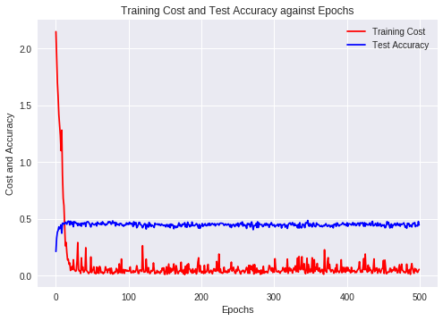

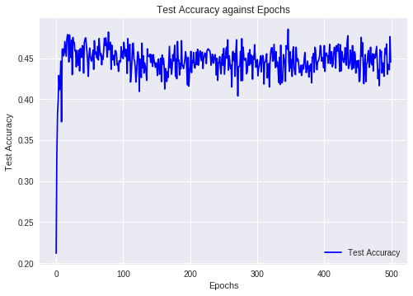

From the results here, we can see that dropouts with keep_prob of 0.9 does not significantly improve results.

Dropout is a regularization technique, and is most effective at preventing overfitting. However, there are several places when dropout can hurt performance.

1. Right before the last layer. This is generally a bad place to apply dropout, because the network has no ability to "correct" errors induced by dropout before the classification happens.
2. When the network is small relative to the dataset, regularization is usually unnecessary. If the model capacity is already low, lowering it further by adding regularization may hurt performance.

Another technique that can replace drop outs is by using batch normalization. Batch normalisation is a technique for improving the performance and stability of neural networks, and also makes more sophisticated deep learning architectures work in practice (like DCGANs). The idea is to normalise the inputs of each layer in such a way that they have a mean output activation of zero and standard deviation of one. This is analogous to how the inputs to networks are standardised.

PART B: Text Classification

The dataset used in this project contains the first paragraphs collected from Wikipage entries and the corresponding labels about their category. You will implement CNN and RNN layers at the word and character levels for the classification of texts in the paragraphs. The output layer of the networks is a softmax layer.

The training and test datasets will be read from ‘train_medium.csv’ and ‘test_medium.csv’ files. The training dataset contains 5600 entries and test dataset contains 700 entries. The label of an entry is one of the 15 categories such as people, company, schools, etc.

The input data is in text, which should be converted to character/word IDs to feed to the networks by using ‘tf.contrib.learn.preprocessing’. Restrict the maximum length of the characters/word inputs to 100. Use the Adam optimizer for training with a batch size = 128 and learning rate = 0.01. Assume there are 256 different characters.

1. Design a Character CNN Classifier that receives character ids and classifies the input. The CNN has two convolution and pooling layers:

• A convolution layer 𝐶1 of 10 filters of window size 20x256, VALID padding, and ReLU neurons. A max pooling layer 𝑆1 with a pooling window of size 4x4, with stride = 2, and padding = 'SAME'.

• A convolution layer 𝐶2 of 10 filters of window size 20x1, VALID padding, and ReLU neurons. A max pooling layer 𝑆2with a pooling window of size 4x4, with stride = 2 and padding = 'SAME'.

Methodology:

1. Read the training and validation data from ‘train_medium.csv’ and ‘test_medium.csv’ files respectively.
2. Convert the text into Character ID.
3. Build the CNN model with 2 convolution layer using ‘tf.layers.conv2d’ for the convolution layer and ‘tf.layers.max_pooling2d’ for the pooling layer.
4. The Output of the CNN model or as it is usually called logits will be used to calculate the cross entropy and accuracy.
5. Accuracy is taken from comparing the output from the model with the validation dataset.

Experiment:

1. Test Accuracy against Epochs

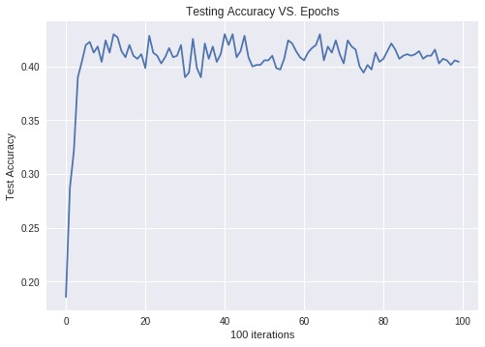

1. Cost Entropy against Epochs

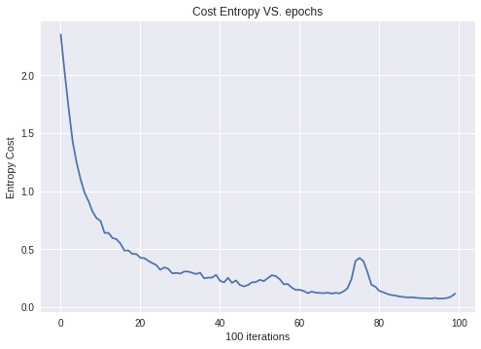

1. Comparison between Train Accuracy and Test Accuracy with Train Error

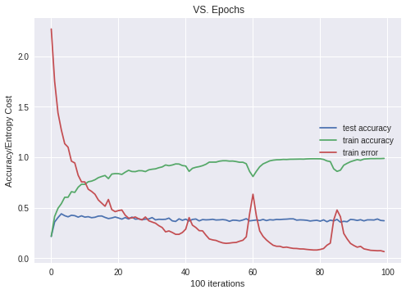

Conclusion:

From the results, testing accuracy for CNN from Character ID converges at 0.42 while test accuracy converges at 0.1. There is some spike in the graph for training error, which could be mitigated by adding dropout method.

1. Design a Word CNN Classifier that receives word ids and classifies the input. Pass the inputs through an embedding layer of size 20 before feeding to the CNN. The CNN has two convolution and pooling layers with the following characteristics:

• A convolution layer 𝐶1 of 10 filters of window size 20x20, VALID padding, and ReLU neurons. A max pooling layer 𝑆1 with a pooling window of size 4x4, with stride = 2 and padding = 'SAME'.

• A convolution layer 𝐶2 of 10 filters of window size 20x1, , VALID padding, and ReLU neurons. A max pooling layer 𝑆2with a pooling window of size 4x4, with stride = 2 and padding = 'SAME'.

Methodology:

1. Read the training and validation data from ‘train_medium.csv’ and ‘test_medium.csv’ files respectively.
2. Convert the text into Word ID.
3. Build the CNN model with 2 convolution layer using ‘tf.layers.conv2d’ for the convolution layer and ‘tf.layers.max_pooling2d’ for the pooling layer.
4. The Output of the CNN model or as it is usually called logits will be used to calculate the cross entropy and accuracy.
5. Accuracy is taken from comparing the output from the model with the validation dataset

Experiment:

1. Accuracy against Epochs

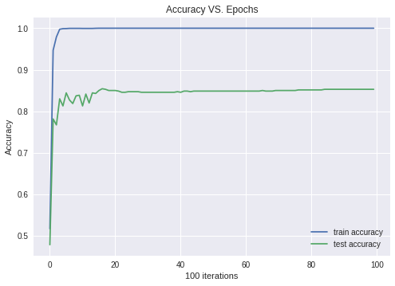

Conclusion:

From this graph, the training accuracy plotted converges at 1.0 while test accuracy converged at 0.86 which can be considered quite good with the small datasets given.

1. Cost Entropy against Epochs

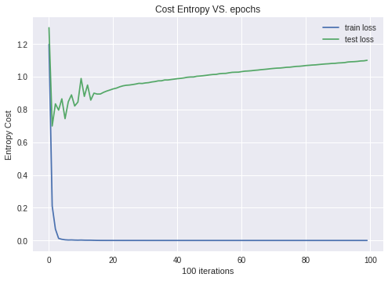

Conclusion:

From this graph, the train cost entropy and the test cross entropy is plotted. It is seen that the test loss or cross entropy plotted keep increasing from early iteration. It is believed because of overfitting the training loss keeps increasing.

1. Design a Character RNN Classifier that receives character ids and classify the input. The RNN is GRU layer and has a hidden-layer size of 20.

Methodology:

1. Read the training and validation data from ‘train_medium.csv’ and ‘test_medium.csv’ files respectively.
2. Convert the text into Character ID.
3. Build the CNN model with 2 convolution layer using ‘tf.layers.conv2d’ for the convolution layer and ‘tf.layers.max_pooling2d’ for the pooling layer.
4. The Output of the CNN model or as it is usually called logits will be used to calculate the cross entropy and accuracy.
5. Accuracy is taken from comparing the output from the model with the validation dataset.

Experiment:

1. Test Accuracy against Epochs

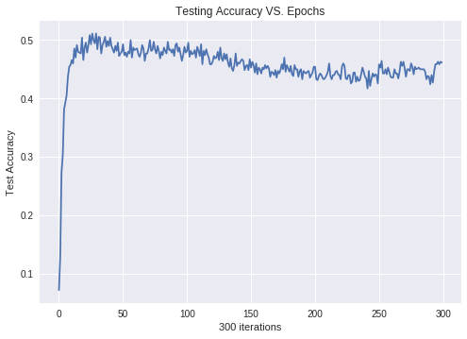

1. Cost Entropy against Epochs

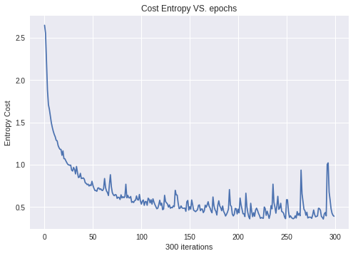

Conclusion:

The graphs shown test accuracy against epochs and the cross entropy against epochs from RNN models that extract the ‘Character ID’ from the text. first graph shows that the test accuracy keeps decreasing from around iteration 80. It is believed that this is caused by overfitting the model as the datasets given is quite small. In the Graph about cross entropy there is also some spike point in the curve which could be mitigated by early stopping or using dropout method.

1. Design a word RNN classifier that receives word ids and classify the input. The RNN is GRU layer and has a hidden-layer size of 20. Pass the inputs through an embedding layer of size 20 before feeding to the RNN.

Methodology:

1. Read the training and validation data from ‘train_medium.csv’ and ‘test_medium.csv’ files respectively.
2. Convert the text into Character ID.
3. Build the CNN model with 2 convolution layer using ‘tf.layers.conv2d’ for the convolution layer and ‘tf.layers.max_pooling2d’ for the pooling layer.
4. The Output of the CNN model or as it is usually called logits will be used to calculate the cross entropy and accuracy.
5. Accuracy is taken from comparing the output from the model with the validation dataset.

Experiment:

1. Accuracy against Epochs

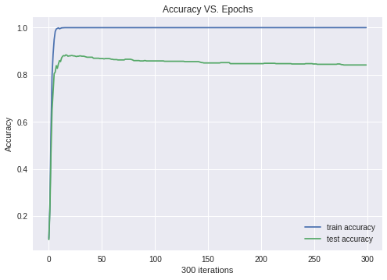

1. Cost Entropy against Epochs

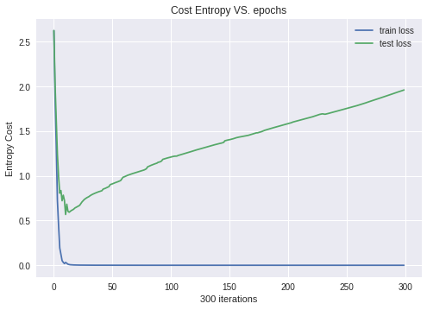

Conclusion:

The first graph shows that the train accuracy converges at 1.0 while the test accuracy converges at 0.8. There is a slight decrease of from around iteration 100 and is believed because of overfitting of the model. In the second graph the test loss keep increasing from iteration 10 ,which also caused by overfitting of the model.

1. Compare the test accuracies and the running times of the networks implemented in parts (1) – (4). Experiment with adding dropout to the layers of networks in parts (1) – (4), and report the test accuracies. Compare and comment on the accuracies of the networks with/without dropout

Methodology:

1. Adding dropout method into all the experiment done above.
2. Adding time method to look at the time take per epoch for every experiment done above.

Experiment:

1. Test Accuracy from CNN and RNN using ‘char id’ and ‘word id’

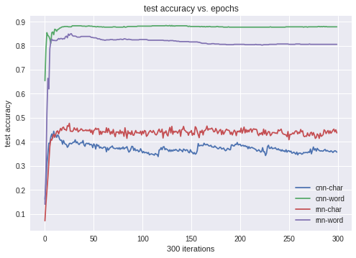

1. Time Taken per Epoch from CNN and RNN using ‘char id’ and ‘word id’

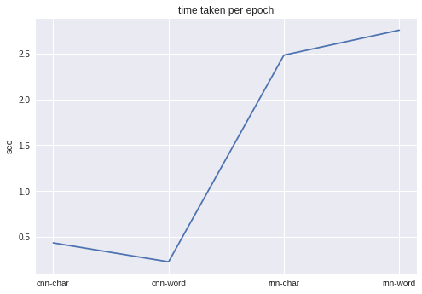

1. Test Accuracy from CNN and RNN using ‘char id’ and ‘word id’ with dropout

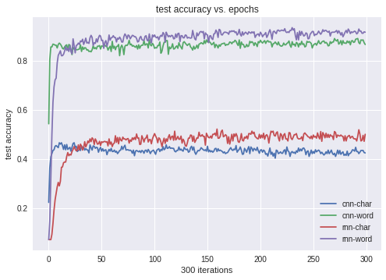

1. Time Taken per Epoch from CNN and RNN using ‘char id’ and ‘word id’ with dropout

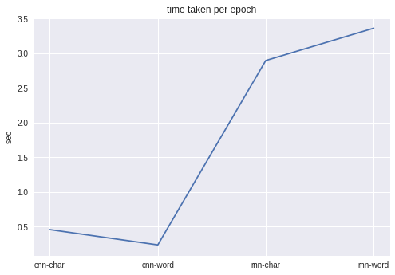

Conclusion:

From the graphs showed, it appears that by the model that takes ‘word id’ as input has better performance which converges at above 0.8 while the model that takes ‘char id’ as input has accuracy that converges at around 0.5. It is because for character it is harder to build the neural network as it needs a lot more sample than a word. It is shown that the time take per epoch for RNN takes a longer time than CNN. Using dropout method takes about 1 sec for 1 epoch.

1. Improving Performance and Comparing Accuracy for RNN-Char and RNN-Word
2. Comparation between 3 RNN cell : Vanilla RNN, GRU, and LSTM with seed number={10,20,30,50,80}

* Seed = 10

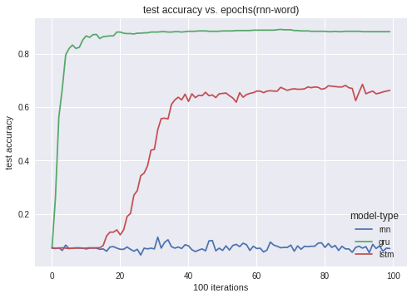

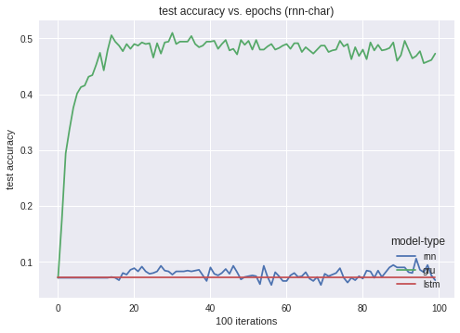

* + Seed = 20

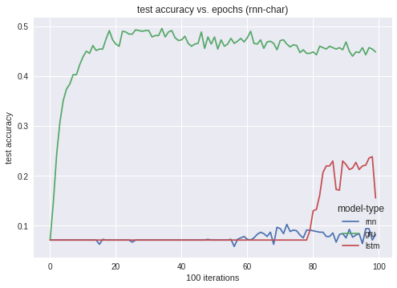

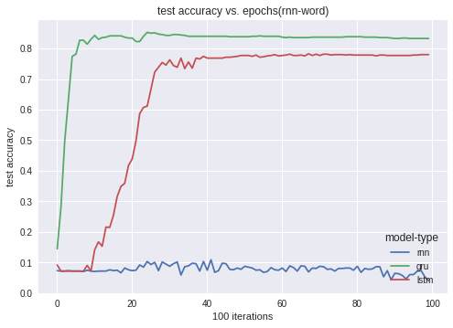

* + Seed = 25

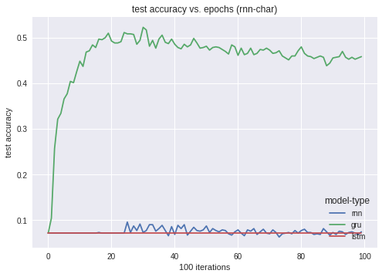

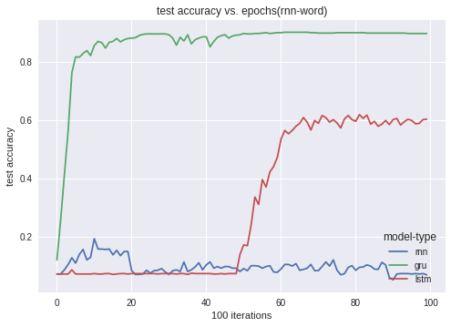

* + Seed = 30

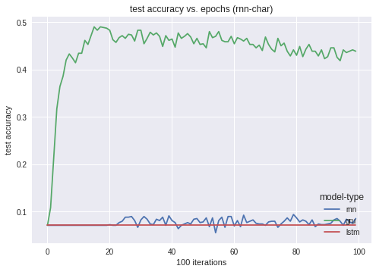

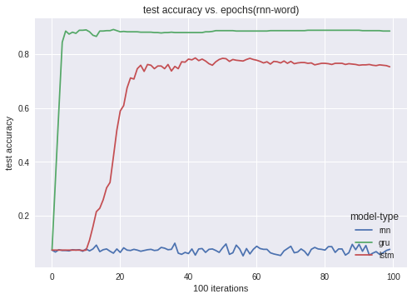

* + Seed = 40

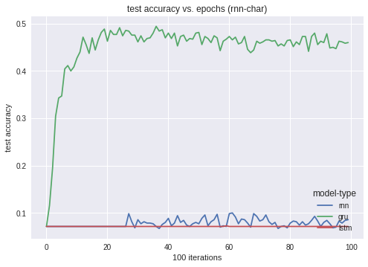

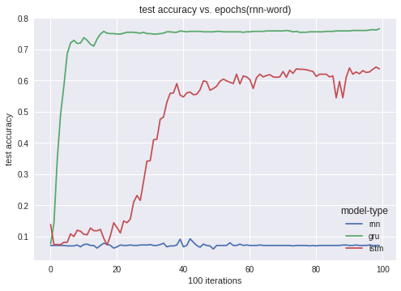

* + Seed = 50

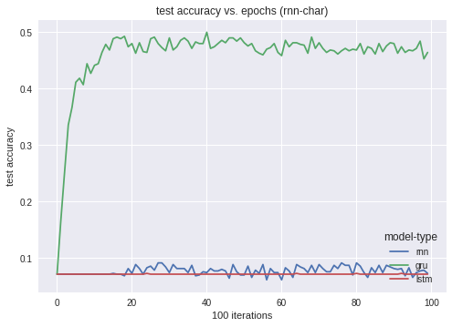

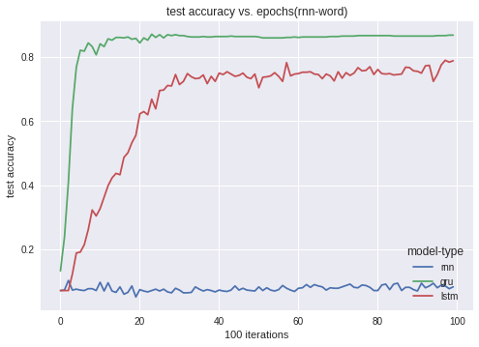

* + Seed = 80

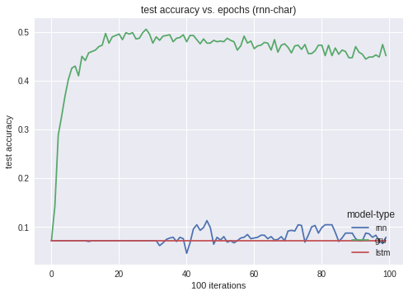



Conclusion:

From all the graph shown above , the best seed is 20, where there is some movement on the lstm line from rnn-char. An it also has the overall best performance compared to other seed numbers that have been tried in this experiment. Overall, the cell that has the best performance is GRU cell, where it usually has an accuracy of above 0.8 while rnn is just fluctuating on 0.714284, whis point also where lstm cell graph has the straight line at. It is believed that there is some problem with the lstm cell, because of the seed numbers.

1. RNN Vanilla RNN/GRU/LSTM Cell 2-Layer
2. RNN-Char with Vanilla RNN

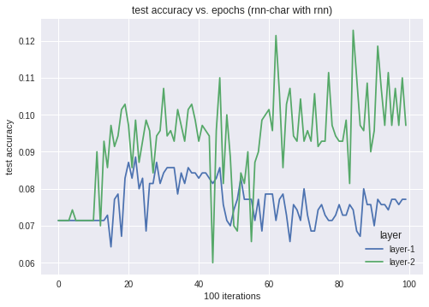

1. RNN-Char with GRU

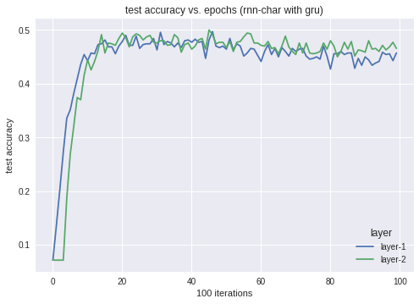

1. RNN-Char with LSTM

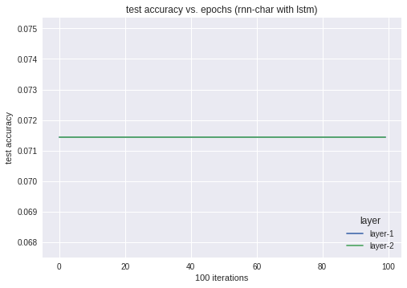

1. RNN-Word with Vanilla RNN

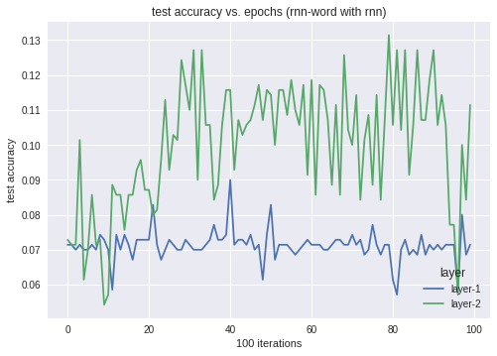

1. RNN-Word with GRU

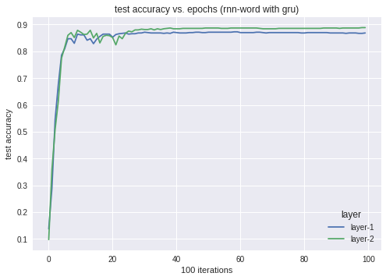

1. RNN-Word with LSTM

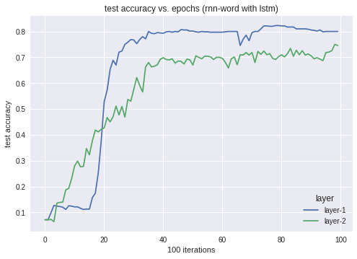

Conclusion:

From all the graph above, it is shown that 2-layer of RNN is better than 1-layer RNN as it is deeper and can compute more complex data than just 1-layer of RNN. The one that has the best performance is also GRU cell.

1. 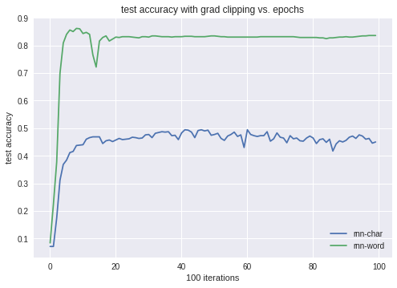RNN Training with Gradient Clipping with threshold = 2.0

Conclusion:

This graph is about 1-layer RNN with GRU cell with threshold 2.0.

This RNN training with Gradient Clipping is quite stable but the performance is a little bit worse than without using Gradient Clipping.